**RollNumber : 21F-9159**

**Section : E**

**Task1**

<!DOCTYPE html>

<html lang="en">

<head>

    <meta charset="UTF-8">

    <meta name="viewport" content="width=device-width, initial-scale=1.0">

    <title>Document</title>

</head>

<body bgcolor="grey">

    <img src="img1.jpg "  alt = "" width="500" height="500" >

   <h1>MY FIRST WEBSITE PAGE </h1>

   <h2>  NAME : SHAYAAN</h2>

   <h2>ROLL NUMBER : 21F-9159 </h2>

   <h3> BRIEF about Me </h3>

   <p> Right now I am doing my bachelors degreee in computer science from FAST UNIVERSITY

    My name is shayan, and I come from faisalabad. I am 21, and I look forward to being a part of this classroom.

     I am interested in watching movies

   </p>

</body>

</html>

**Output**

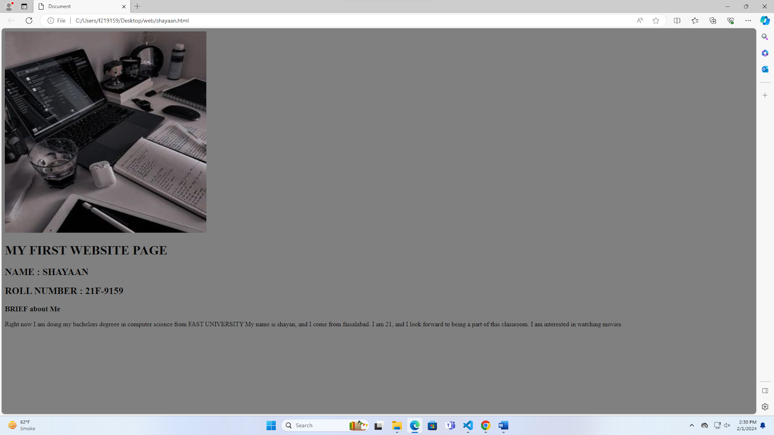

**Task 2**

<!DOCTYPE html>

<html lang="en">

<head>

    <meta charset="UTF-8">

    <meta name="viewport" content="width=device-width, initial-scale=1.0">

    <title>Document</title>

</head>

<body bgcolor="grey">

    <b> this text is bold </b>

    <br>

    <strong> this text is strong </strong>

    <br>

    <big>this is big text </big>

    <br>

    <i> this is italic text  </i>

    <br>

    <em> this is emphasis text</em>

    <br>

    <code>this is computer output</code>

    <br>

    this is <sub>subscript </sub> and <sup>superscript</sup>

</body>

</html>

**Output**

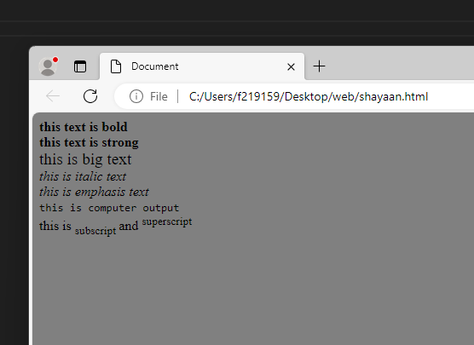

**Task3**

<!DOCTYPE html>

<html lang="en">

<head>

    <meta charset="UTF-8">

    <meta name="viewport" content="width=device-width, initial-scale=1.0">

    <title>Document</title>

</head>

<body bgcolor="">

<center><img src="img.png"  alt="" width=" 500" height="500"></center>

</body>

</html>

**Output**

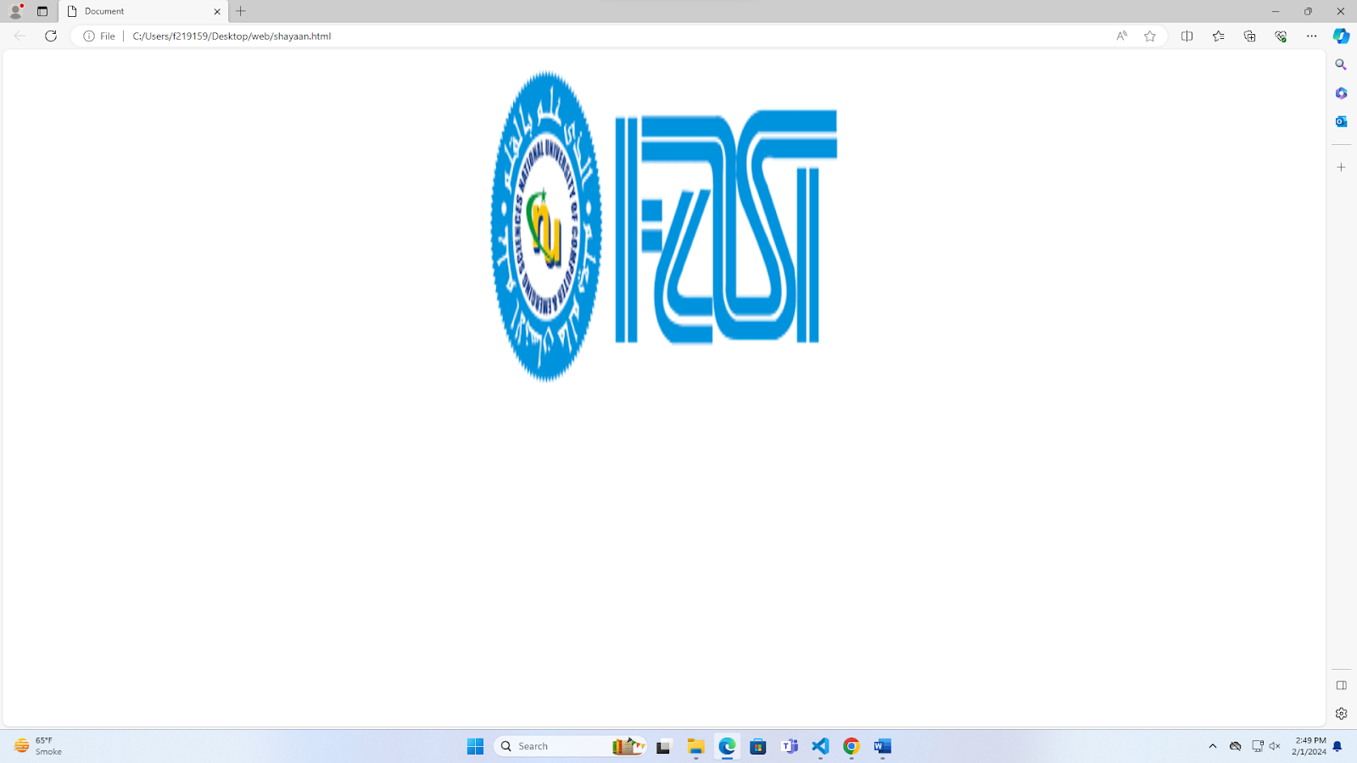

**Task 4**

<!DOCTYPE html>

<html lang="en">

<head>

    <meta charset="UTF-8">

    <meta name="viewport" content="width=device-width, initial-scale=1.0">

    <title>Document</title>

</head>

<body bgcolor="">

 <a href="https://nu.edu.pk/ "><center><img src="img.png"  alt="" width=" 500" height="500"></center></a>

</body>

</html>

**Output**

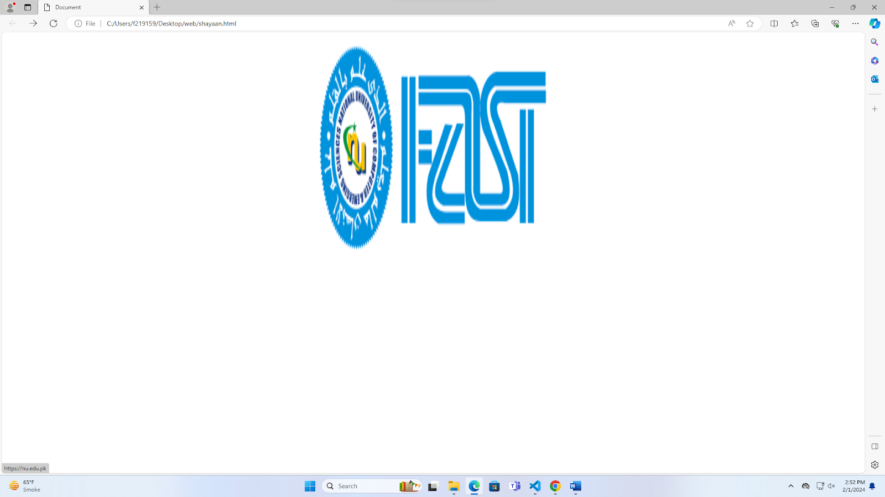

**Task 5**

<!DOCTYPE html>

<html lang="en">

<head>

    <meta charset="UTF-8">

    <meta name="viewport" content="width=device-width, initial-scale=1.0">

    <title>Document</title>

</head>

<body bgcolor="">

  <h1>HTML Lists</h1>

  <h2>unordered List</h2>

<p>we have books on a variety of languages</p>

<ul>

<li>Oracle </li>

<li>jave</li>

<li>HTML</li>

<li>css</li>

</ul>

<h2>Ordered List </h2>

<p>follow these steps to install Jave:</p>

<ol>

    <li>Download the software</li>

    <li>Extract to a folder</li>

    <li>Double clik the executable to run</li>

</ol>

</body>

</html>

**Output**

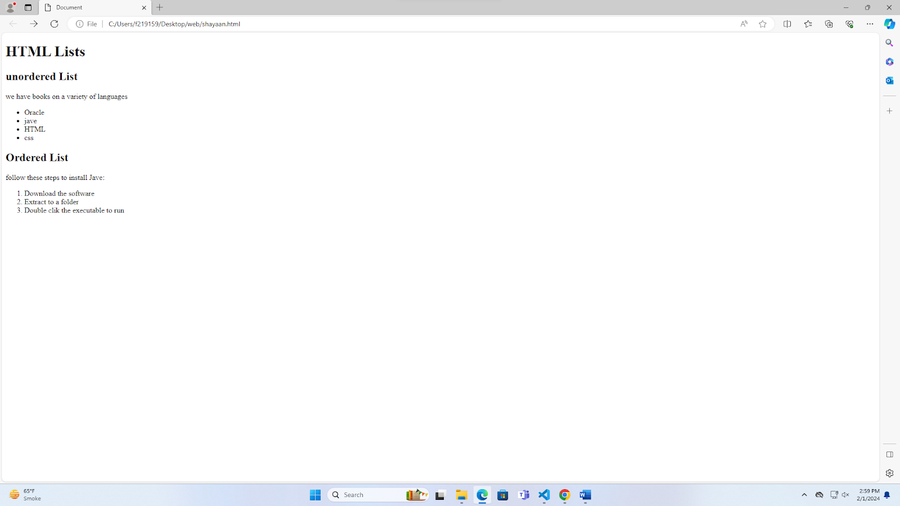

**Task 6**

**<!DOCTYPE html>**

**<html lang="en">**

**<head>**

**<meta charset="UTF-8">**

**<meta name="viewport" content="width=device-width, initial-scale=1.0">**

**<title>Document</title>**

**</head>**

**<body>**

**<table border="" width="400px" height="200px" >**

**<tbody>**

**<tr>**

**<td rowspan="2"> april</td>**

**<td></td>**

**<td></td>**

**</tr>**

**<tr>**

**<td></td>**

**<td></td>**

**</tr>**

**<tr>**

**<td></td>**

**<td></td>**

**<td></td>**

**</tr>**

**<tr>**

**<td></td>**

**<td></td>**

**<td></td>**

**</tr>**

**<tr>**

**<td></td>**

**<td></td>**

**<td></td>**

**</tr>**

**</tbody>**

**</table>**

**</body>**

**</html>**

**Output**

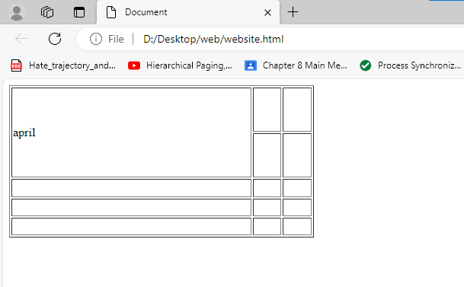

**Task 7**

**<!DOCTYPE html>**

**<html lang="en">**

**<head>**

**<meta charset="UTF-8">**

**<meta name="viewport" content="width=device-width, initial-scale=1.0">**

**<title>Document</title>**

**</head>**

**<body>**

**<table border="1" style="width: 400px; height: 250px;">**

**<tr>**

**<td colspan="3"><center>2022</center>**

**</td>**

**</tr>**

**<tr>**

**<td></td>**

**<td ></td>**

**<td ></td>**

**</tr>**

**<tr>**

**<td rowspan="2" colspan="2"><center>Fiesta</center></td>**

**<td ></td>**

**</tr>**

**<tr>**

**<td ></td>**

**</tr>**

**<tr>**

**<td ></td>**

**<td></td>**

**<td ></td>**

**</tr>**

**</table>**

**</body>**

**</html>**

**output**

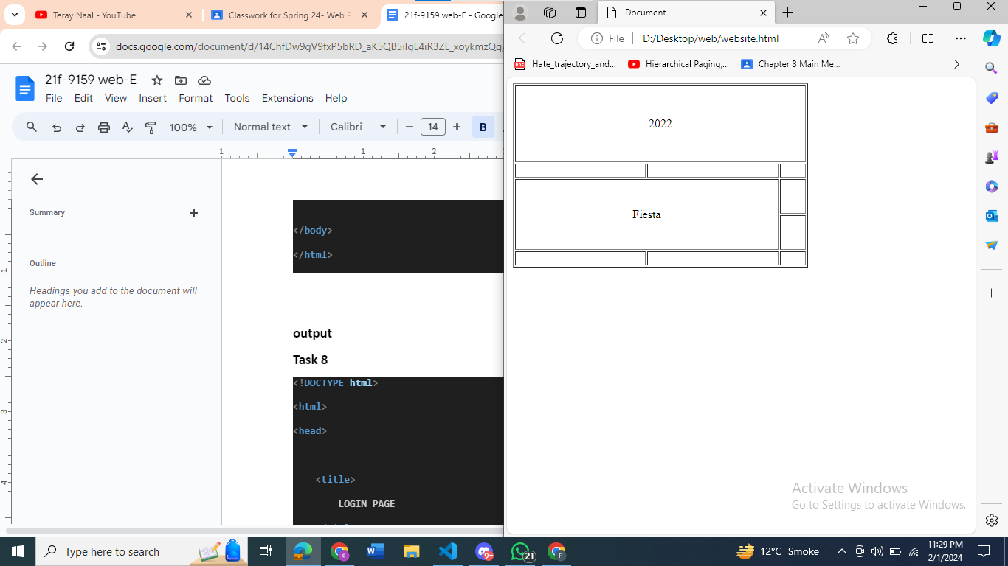

**Task 8**

**<!DOCTYPE html>**

**<html>**

**<head>**

**<title>**

**LOGIN PAGE**

**</title>**

**</head>**

**<body>**

**<center><h2>Welcome to FAST LOGIN <img src="icon.png"></h2></center>**

**<center><h3>Please sign-in to your account.</h3></center>**

**<br>**

**<center><label>Email</label></center>**

**<center><input type="text" name="Email" placeholder="Email "></center>**

**<br>**

**<center><label>Password</label></center>**

**<br>**

**<center><input type="password" name="password" placeholder="password "></center>**

**<br>**

**<center><a href="#">Forgot password?</a></center>**

**<br>**

**<center><label><input type="checkbox">Remember Me</label> </center>**

**<br>**

**<center><button class="btn">sign in</button></center>**

**<center><p>New on our platform?**

**<a href="#">Create an account </a></p></center>**

**</body>**

**</html>**

**Output**

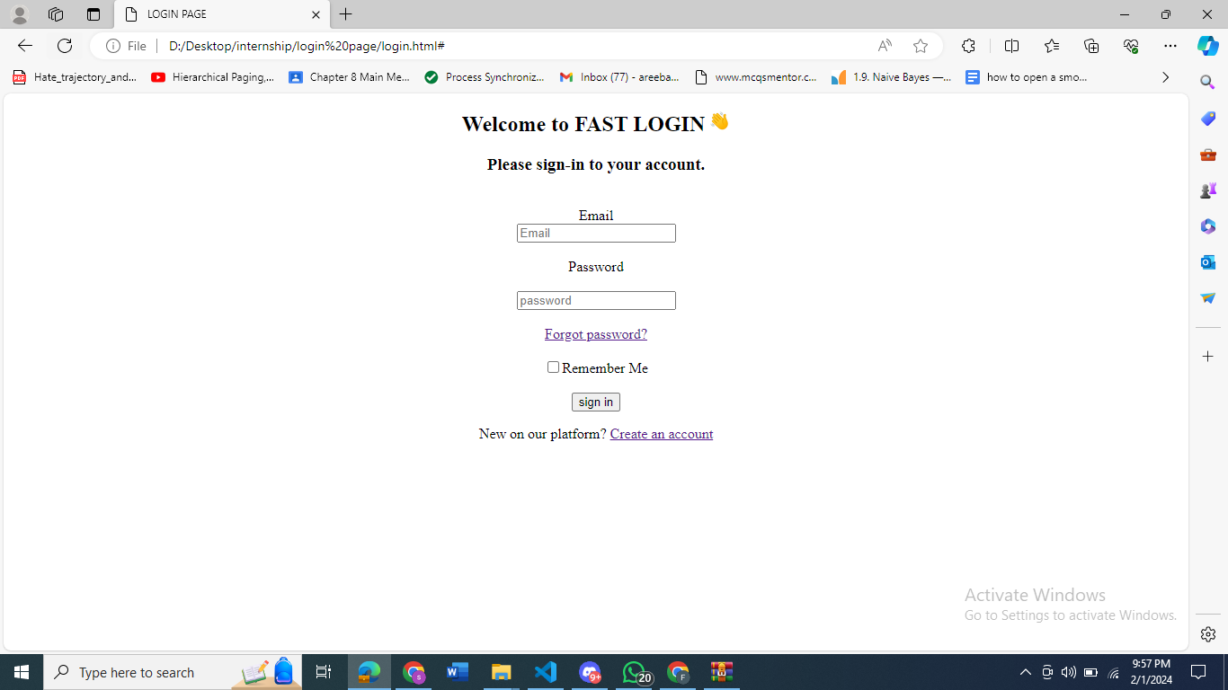

**task 9**

**<!DOCTYPE html>**

**<html lang="en">**

**<head>**

**<meta charset="UTF-8">**

**<meta name="viewport" content="width=device-width, initial-scale=1.0">**

**<title>Document</title>**

**</head>**

**<body>**

**<center>**

**<h1>Pete's Pizza Delivery </h1>**

**<h2>Online order Form</h2>**

**</center>**

**<label> *NAME</label>**

**<input type="text" name="" placeholder="name">**

**<label>TEL</label>**

**<input type="text" name="" placeholder="tel">**

**<br>**

**<br**

**<label> *Address</label>**

**<input type="text" name="" placeholder="Address">**

**<label>Email</label>**

**<input type="text" name="Email" placeholder="Email">**

**<br>**

**<br>**

**<label> *town/city</label>**

**<input type="text" name="" placeholder="city">**

**<br>**

**<br>**

**<label> *postcode</label>**

**<input type="text" name="" placeholder="code">**

**<br>**

**<br>**

**<center>*required feilds</center>**

**<br>**

**<h3> Toppings</h3>**

**<label><input type="checkbox">Margherita</label>**

**<br>**

**<label><input type="checkbox">Four Seasons</label>**

**<br>**

**<label><input type="checkbox">Meat feast</label>**

**<h3> Size </h3>**

**<label><input type="checkbox">Small</label>**

**<br>**

**<label><input type="checkbox">medium</label>**

**<br>**

**<label><input type="checkbox">large</label>**

**<h3> Extra</h3>**

**<label><input type="checkbox">Mushrooms</label>**

**<br>**

**<label><input type="checkbox">green peppers</label>**

**<br>**

**<label><input type="checkbox">anchories</label>**

**<br>**

**<label><input type="checkbox">extra cheese</label>**

**<center><button>submit</button></center>**

**</body>**

**</html>**

**output**

